*Orléans Softball / Balle-molle Orléans*

*2025 Report*

***A Note of Gratitude***

*To the coaches, assistant coaches, and volunteers who made this season possible.*

It is only through your generosity in time and effort that Orléans Softball can provide its program.

Each division had its own purpose towards the development of our players, and you all played a significant role in that process. Your contributions are immensely appreciated.

*On behalf of the hundreds of players who have experienced the thrills of local softball,*

***Thank you.***

**ANNUAL REPORT**

**REGISTRATION**

|  |  |  |  |  |
| --- | --- | --- | --- | --- |
| Division | Boys | Girls | NB | Total |
| U6 | 51 | 27 | ~ | 78 |
| U8 | 42 | 29 | ~ | 71 |
| U11 | 40 | 60 | ~ | 100 |
| U13 | 21 | 26 | ~ | 47 |
| U18 | 32 | 27 | 1 | 60 |
|  | **186** | **169** | **1** | **356** |
| Refund&waitlist | **Additional** |  |  | **32** |

**2026 OBJECTIVES**

* 5% growth in registration hope to reach 400 players
* Recruit more volunteers for regular season activities
* Field more select teams hopefully 2 girls and 1 boys team
* Improve umpire skills – host another clinic – increase mentoring
* Encourage coaches to attend online or in person courses
* More indoor skills development over the winter months in the gymnasium.
* Review all rules and age groups to match with Softball recreation suggestions
* Review yearend rules such as tie breakers. Communicate early all rules.
* Post all dates by April 1 for regular season and year end dates
* Evaluations for pitchers prior to team formations division U11 to U18

**YEAR IN REVIEW**

Prior to registration, efforts were focused on the following:

* The creation of a new email account, since the previous account had been lost
* A new platform was reviewed and purchased to allow for registration, scheduling for teams and umpires as well as maintaining websites. SPORTSHEADZ was the successful vendor, will continue to use them again for 2026 season.
* Updated of all our corporate documentation, from rules and regulations to waivers and administrative templates, updated.

Marketing expenditures were focussed primarily online on Facebook and Google, with ad spending being the most effective on such platforms.

**LESSONS LEARNED/ACTION PLAN**

***These are some of the lessons we’ve learned, amongst others not listed for brevity.***

* More volunteers other than board members are required in order to have a smoother operation during the season such as convenors at each age group.
* Games/practices must be evenly distributed throughout the week to account for umpire/field availability.
* All rules for each division should be established at the beginning of the season and remain unchanged until the end of the season.
* Call up procedures should be documented and well communicated to all coaches and teams.
* Disciplinary procedures need to be updated and communicated to all umpires, coaches, board members. Make sure that this template is well-known and understood by all.
* Players that identify as pitcher need to be evaluated to ensue even distribution on teams.
* Tournament formats were largely successful, however will review each level again once number of teams are known and will try to use fields in proximity of each other and allow enough time for breaks for washrooms and eating.
* Need to highlight different players on the web perhaps a play of the week for each division.
* Review regular house-league and year-end tournaments/funday rules
* Implement new yearly promotion (refer a friend) earlier registration.
* Improve social media presence to every game day.
* Players that identify as pitcher on registration must come to evaluation so that they can be divided evenly between the teams.
* Use gym sessions for more learn to pitch and to improve current pitchers. Different nights for the different levels.

Survey Results:

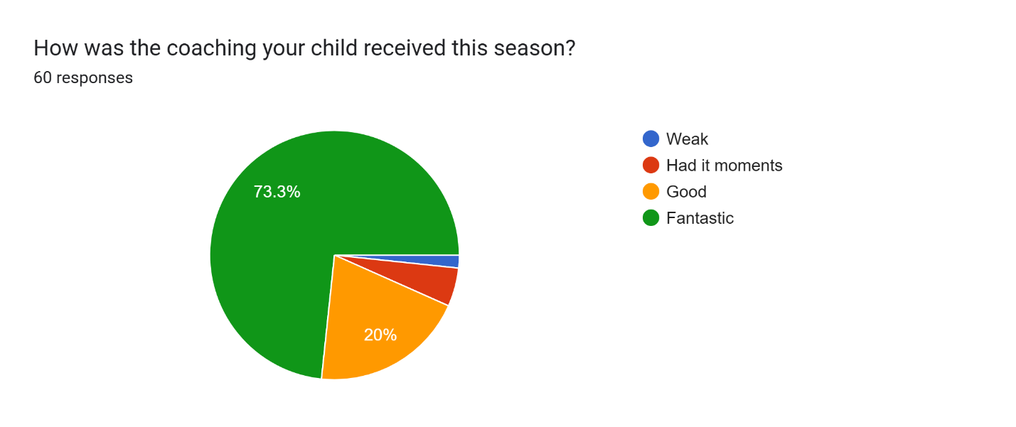

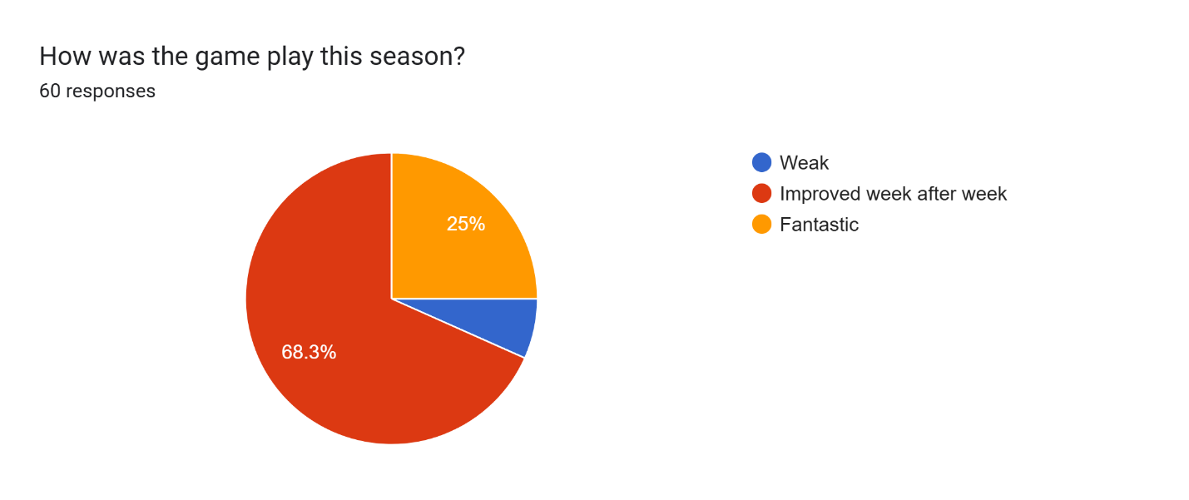

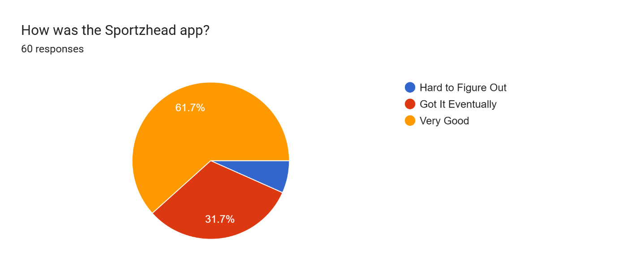

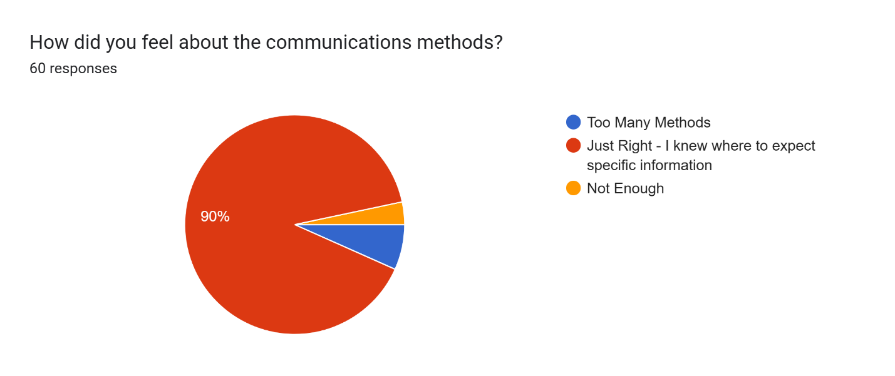

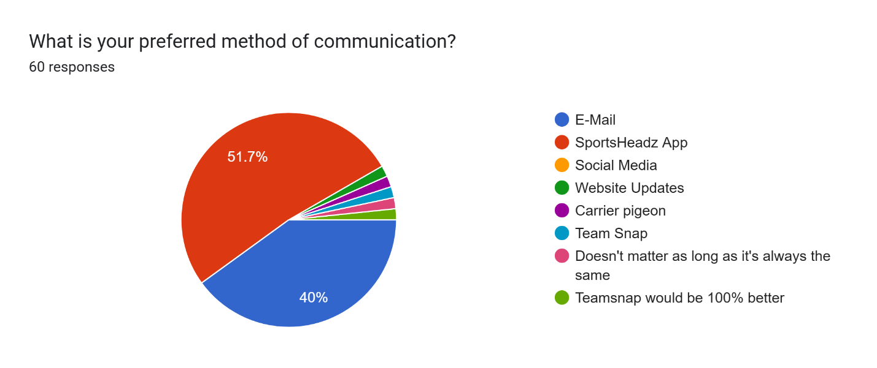

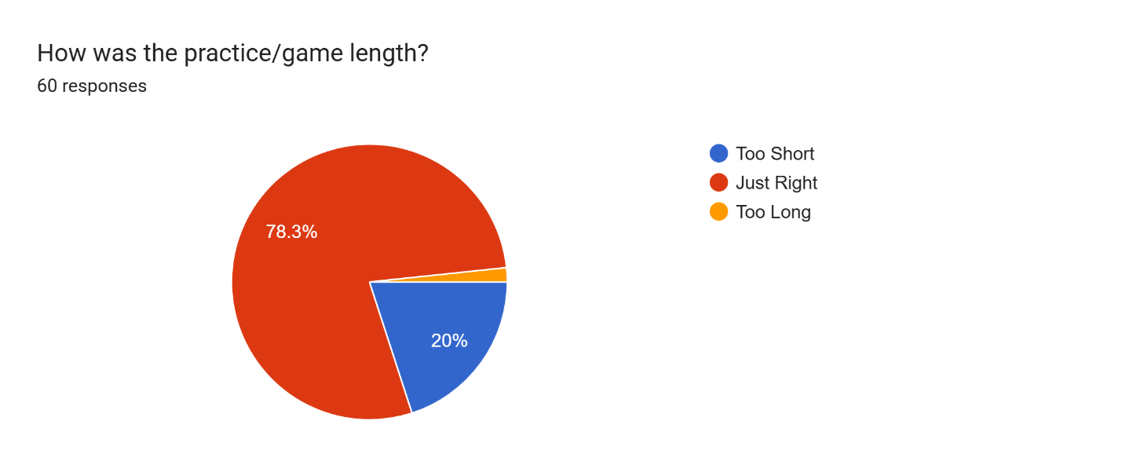

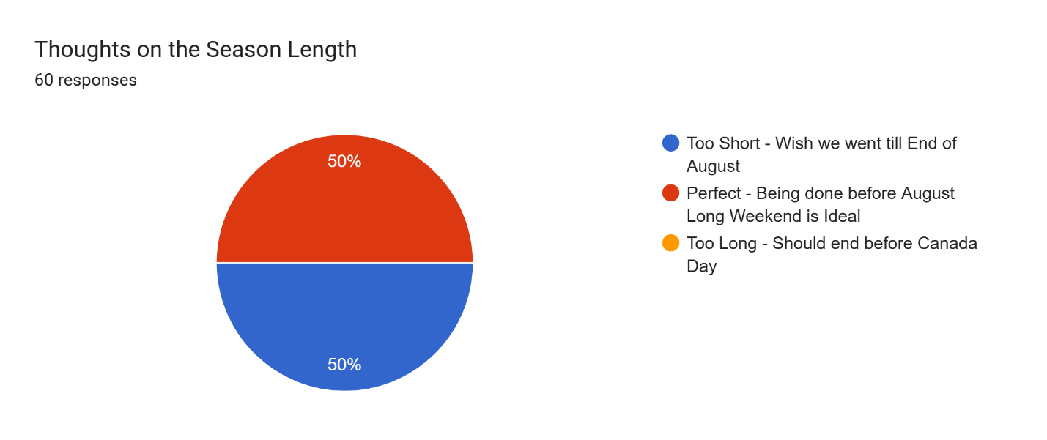

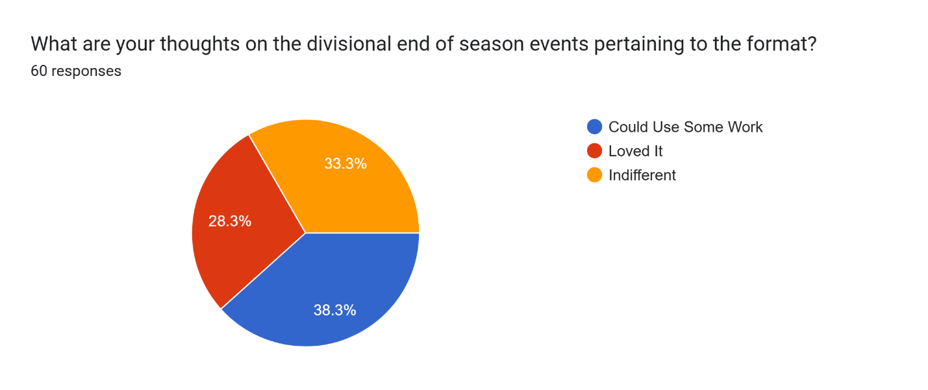

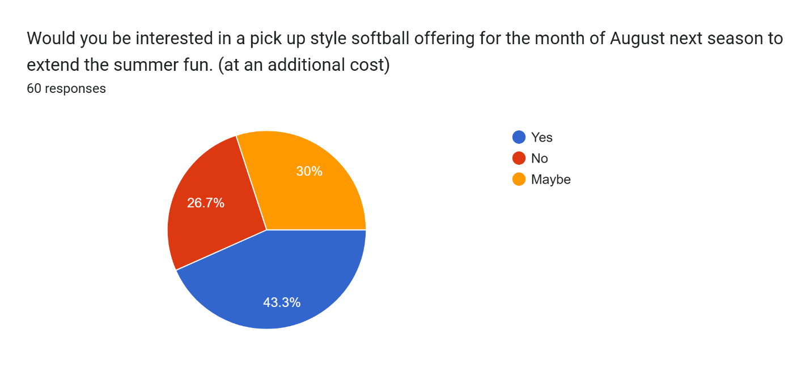

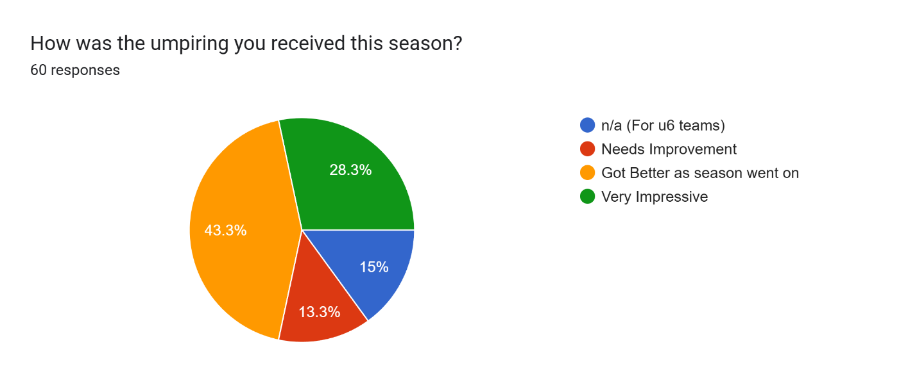

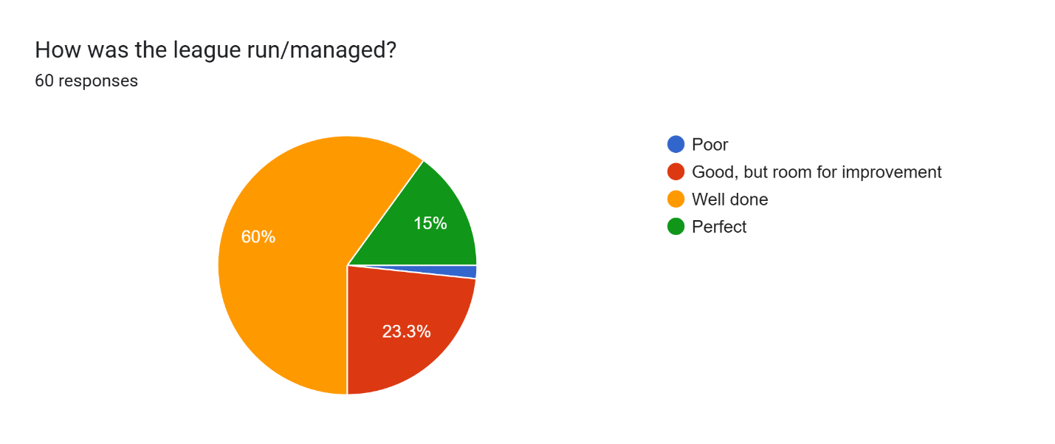

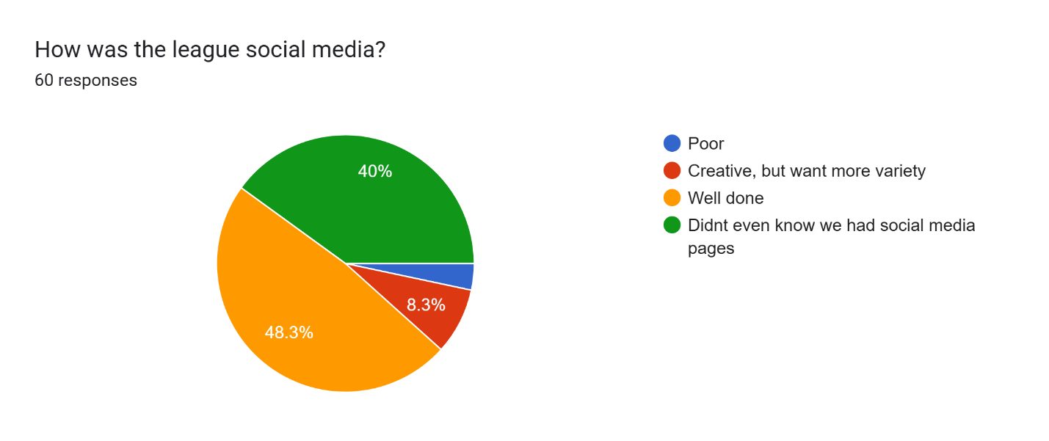

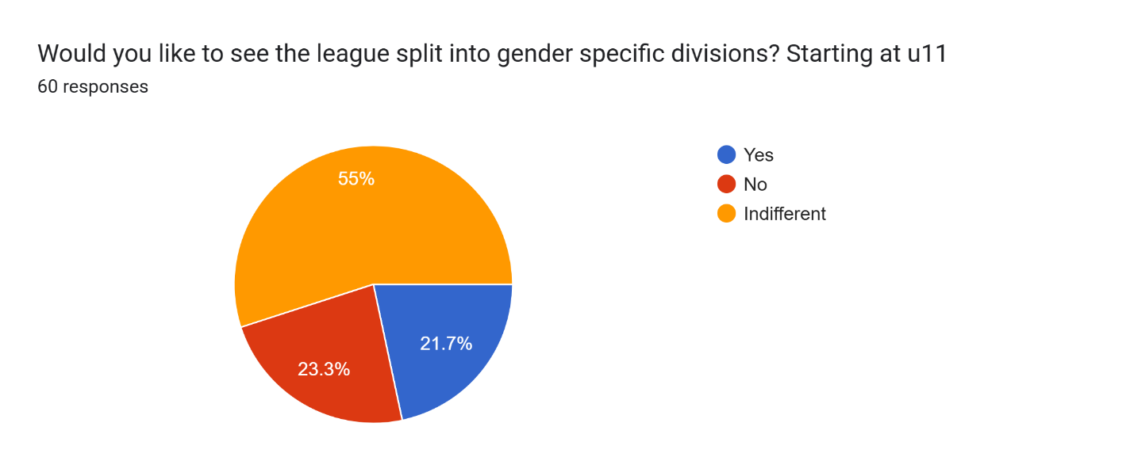

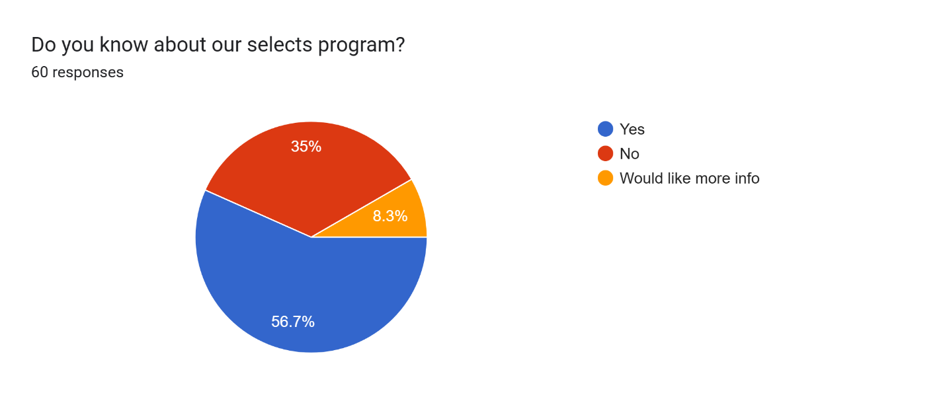

**FINAL THOUGHTS**

Thank you everyone who played even a small role in this season’s operations. Rebuilding this league is both immensely exhausting and rewarding. Together each year gets better all comments are reviewed to make improvements.

Regards,

Brenda Rutledge

President